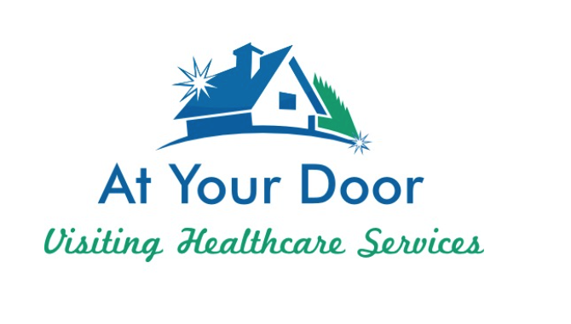
You may have seen our At Your Door Nurse practitioner around the building! Meet Amanda Esch!

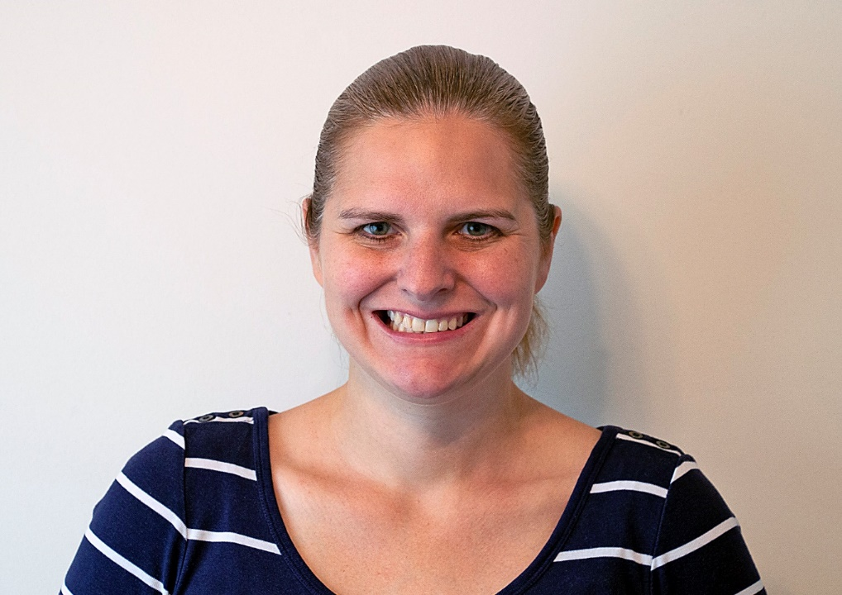

Amanda Esch received her Bachelors of Science in Nursing and her Masters Of Science in Family Nurse Practitioner at Franciscan University of Steubenville.

She has been a Nurse since 2007 and a Nurse Practitioner since 2009. As a Nurse Amanda worked at Nationwide Children’s Hospital on the Neuroscience Unit.

Amanda joined At Your Door Healthcare Services in 2018. She visits several assisted living, Independent Living and Skilled facilities throughout the community.

Amanda lives in Heath with her husband and 5 young children, 3 girls and 2 boys. They enjoy hiking, downhill skiing and going to theme parks!

