Meet Nurse Practitioner Angel Washington

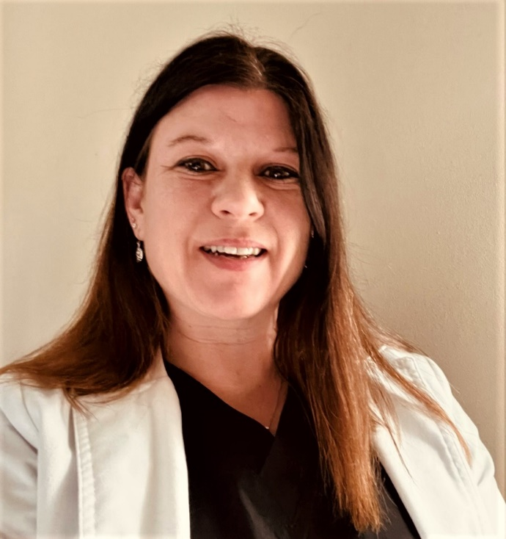

Angelic (Angel) has 17 years of experience as a healthcare professional. She is an ANCC board certified nurse practitioner, with a Doctorate in Nursing Practice from Medical University of South Carolina. She specializes in adult-geriatric primary care with a sub-specialty in mental health. She is passionate about providing quality, compassionate, and comprehensive primary care and mental health services to adolescents and adults.

Angel provides evaluations and medication management with special attention to individual needs, which she approaches with patience, warmth, understanding, and helpful explanations that facilitate treatment and the patient's sense of comfort and trust. Angel believes in supporting individuals on their journey toward their own wellness through a nonjudgmental, compassionate and collaborative approach.

In her free time, Angel enjoys running, reading, hiking/riding trails, concerts, traveling and spending time with family, friends and her German Shepherd dog Shelby who is obtaining certification as a Therapy Service Dog.

