Meet At Your Door: Visiting Healthcare Services
Nurse Practitioner
Anthony Durning

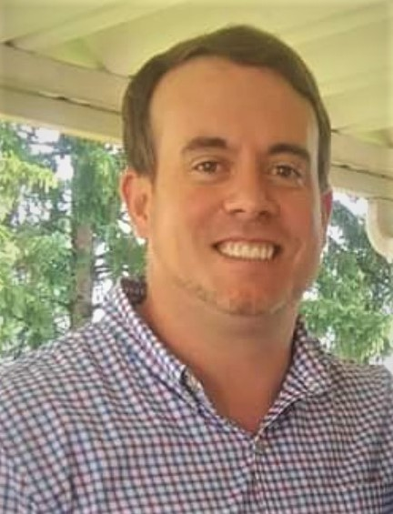

Anthony received his Bachelors of Science degree in nursing from Wright State University in 2012. He worked at Grandview Hospital in Dayton in the surgical and medical ICU for a total of 7 years. Anthony then went on and received his Acute Care Nurse Practitioner degree at Walden University in 2019. Prior to joining At Your Door, Anthony worked for a private practice group taking care of both acute and chronic conditions for Kettering Health Network. He has also worked for a local hospice group, as he has always had a passion advocating for patients during end-of-life care. Anthony currently resides in Waynesville Ohio with his wife and 2 children Cade, who is 5 and Quinn who is 1! When not working caring for our local senior population, Anthony enjoys working out, cooking, traveling and reading.

