Meet At Your Door Nurse Practitioner Brian Weikert!

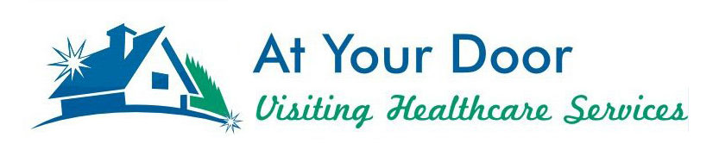

Meet Brian Weikert, an Adult Gerontology Nurse Practitioner. Brian has been a Registered Nurse for 22 years with over 19 years in School Nursing and over 12 years in Critical Care. He works as a School Nurse in New Albany, as well as, joined the At Your Door team in 2019.

Brian received his Bachelor of Science in Nursing from Mount Carmel College of Nursing in 1997. He obtained his Master of Science in Nursing with a focus in Clinical Nurse Leadership from Otterbein University in 2015. And last year, he completed his Post-Master’s Certification as a Nurse Practitioner in Adult Gerontology from the University of Cincinnati.

In his free time, Brian has been a soccer coach at many levels for the last 17 years. He’s currently an assistant coach with the women’s team at Capital University. Brian lives in Westerville with his wife, Gwen and their four children, Daniel, Ellen, Gabriel and Owen. Brian enjoys supporting his children throughout the year in their activities and is an avid Star Wars fan and collector!

Hello to our beloved Avondale residents,

We are excited to share a relationship we have with At Your Door: Visiting Healthcare Services and would like to “introduce you” to their services!

At Your Door provides compassionate Nurse Practitioner services to our residents when you need them!

The beauty of their services is that it costs you nothing more than what you pay currently! They will bill your insurance directly and accept nearly all insurance. You may have a co-pay similar to a regular in-office visit. They can provide EVERYTHING that would be done in an office setting while in the comfort of your own home/apartment. They can arrange for x-rays, labs or any therapy in addition to our services if they are ever needed. Their Nurse Practitioner can provide head to toe assessments, care for you when you are not feeling well, order and manage your medications, order and interpret lab results if they are ever needed, and more!

Sometimes, it can be very difficult for you to get to your primary care provider, and for some, it may also be difficult for your family members if they are the ones that must provide that transportation for you. Our personal At Your Door provider becomes your primary care provider and you never have to go out to an office again! Their in-home services also prevent you from encountering the normal germs and viruses that you may come into contact with at a normal doctor’s office, keeping you healthier. You do NOT have to be “home bound” to be seen by At Your Door, but if it is taxing for you or if you have concerns about going out to see your primary care doctor, At Your Door can get your services covered by your insurance.

At Your Door employs some of the best and most compassionate care providers that work directly with…and in coordination with our community’s staff. Your provider will also communicate with any specialists that you may currently see, ensuring a process that is effortless for you, and provides care that you deserve.

Please speak with a member of our Executive team to set up a visit from our At Your Door provider today or call the office at 614-284-4114!!!

