Meet our At Your Door Nurse Practitioner
Carla Ledbetter!

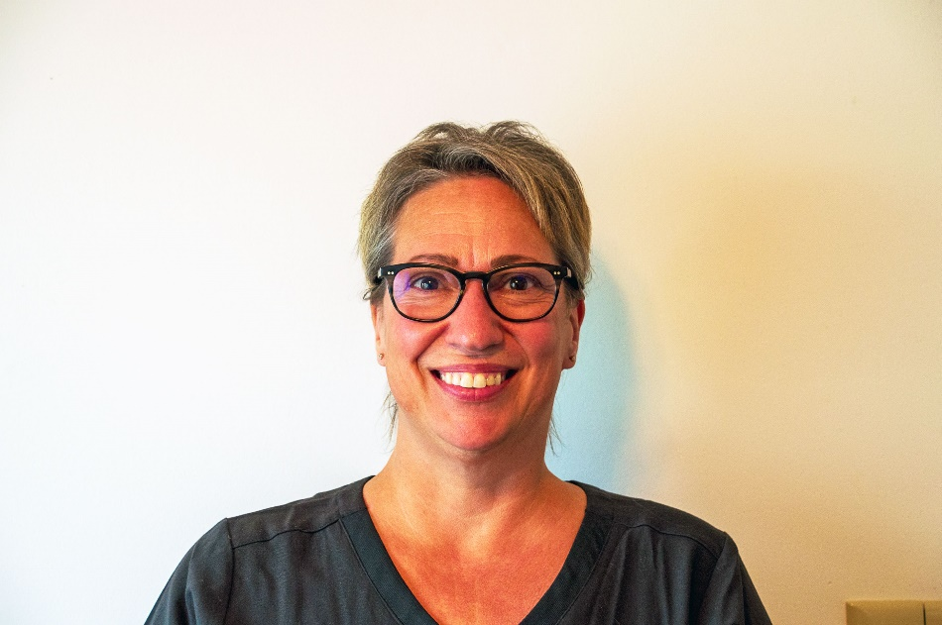

Carla Ledbetter is a Certified Family Nurse Practitioner who graduated from The Ohio State University. She recently joined At Your Door Visiting Healthcare Services. She brings 20+ years of experience as a Registered Nurse practicing primarily in acute care facilities. She specialized in Congestive Heart Failure and Heart Transplant recipients along with Assist Device recipients for the last 10 years of her career.

Carla has been married for over 29 years to her husband, Mark. They have three children, the youngest in his senior year of high school. She loves to spend time with her family. Looks forward to "coffee chat" with her mom and extended family every week. Enjoys reading, Clearwater beach, yoga, and watching her husband and both daughters coach softball.

Hello to our valued residents!

We have begun a new and exciting relationship with At Your Door: Visiting Healthcare Services and would like to “introduce you” to their services!

At Your Door provides compassionate Nurse Practitioner services to our residents when you need them!

The beauty of their services is that it costs you nothing more than what you pay currently! They will bill your insurance directly and accept nearly all forms of insurance. You may have a co-pay similar to a regular in-office visit that you have with your current primary care provider. They can provide EVERYTHING that would be done in an office setting while in the comfort of your own home/apartment. They can arrange for x-rays, labs or any therapy in addition to our services if they are ever needed. Their Nurse Practitioners can provide head to toe assessments, care for you when you are not feeling well, order and manage your medications, order and interpret lab results if they are ever needed, and more!

Sometimes, it can be very difficult for you to get to your primary care provider, and for some, it may also be difficult for your family members if they are the ones that must provide that transportation for you. Our personal At Your Door provider becomes your primary care provider and you never have to go out to an office again! Their in-home services also prevent you from encountering the normal germs and viruses that you may come into contact with at a normal doctor’s office, keeping you healthier. You do NOT have to be “home bound” to be seen by At Your Door, but if it is taxing for you or if you have concerns about going out to see your primary care doctor, At Your Door can get your services covered by your insurance.

At Your Door employs some of the best and most compassionate care providers that work directly with…and in coordination with our community’s staff. Your provider will also communicate with any specialists that you may currently see, ensuring a process that is effortless for you, and provides care that you deserve.

Please speak with a member of our Executive team or call the At Your Door office to set up a visit from an At Your Door provider today!

At Your Door: 614-284-4114

