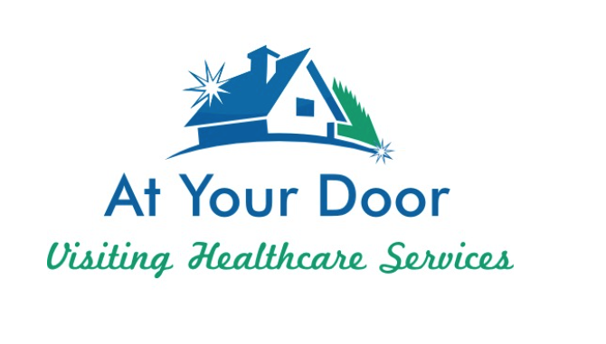
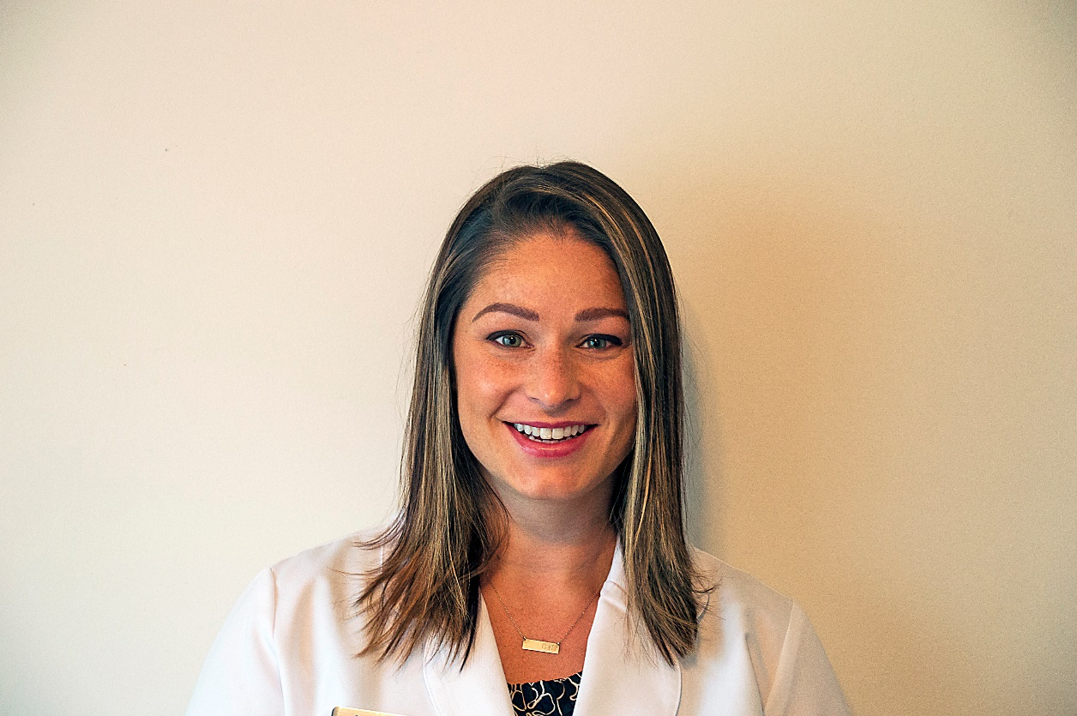

Cassaundra Finney is an Adult-Gerontology Primary Care Nurse Practitioner. She graduated with her Bachelor’s degree from The Ohio State University College of Nursing while playing trombone for The Ohio State University Marching Band. She obtained her Master's degree from The University of Cincinnati, but will always consider herself a Buckeye. She has over seven years of experience working with critically ill patients in the Intensive Care Unit at Riverside Methodist Hospital, and considers geriatrics her third love.

Cassaundra and her husband Brant are new parents of twin girls and also have a 12-pound Australian Shepard Winnie. Her husband works as a lender for JP Morgan Chase in Polaris. When she isn’t caring for her patients, you will most likely find the five of them camping, boating, relaxing at a bonfire. They recently built a house in Sunbury and is excited grow new roots on eight acres of fresh four wheeling land.

Good morning to our valued families!

We are excited to begin a new relationship with At Your Door: Visiting Healthcare Services and would like to introduce you to their services!

At Your Door provides compassionate Nurse Practitioner services to our residents when you need them!

The beauty of their services is that it costs you nothing more than what you pay currently! They will bill your insurance directly and accept nearly all insurance. There may be a co-pay similar to a regular in-office visit. They can provide EVERYTHING that would be done in an office setting while in the comfort of your loved one’s own home/apartment. They can arrange for x-rays, labs or any therapy in addition to our services if they are ever needed. Their Nurse Practitioner can provide head to toe assessments, care for you when you are not feeling well, order and manage medications, order and interpret lab results if they are ever needed, and more! Anything that your primary care physician can do, will be provided while in the comfort of your own apartment!

Sometimes, it can be very difficult for you to get to your primary care provider. Our personal At Your Door provider becomes your primary care provider and you never have to go out to an office again! Their in-home services also prevent you from encountering the normal germs and viruses that you may come into contact with at a normal doctor’s office, keeping you healthier. You do NOT have to be “home bound” to be seen by At Your Door, but if it is taxing for you or if you have concerns about going out to see your primary care doctor, At Your Door can get your services covered by their insurance and except all insurance.

At Your Door employs some of the best and most compassionate care providers that work directly with…and in coordination with our community’s staff. Your provider will also communicate with any specialists that you may currently see, ensuring a process that is effortless for you, and provides care that you deserve. They will also remain in contact with a Power of Attorney if you have one regarding your health and any issues you may have.

Please speak with a member of our care staff or Executive team to set up a visit from an At Your Door provider today! You can also contact the At Your Door office at 614-284-4114.

