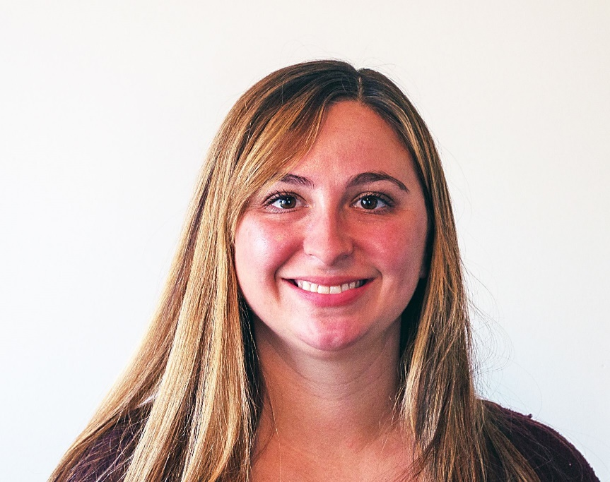

Cierra Ramey received her Bachelors of Science in Nursing at Ohio University and her Masters of Science in Family Nurse Practitioner at Chamberlain University. She has been a nurse since 2012. As a nurse she worked in skilled nursing and home health settings. Cierra joined At Your Door in 2020 and visits assisted living, independent living and skilled facilities throughout the community. She lives in Circleville with her husband and son. She enjoys spending time with her family, traveling and reading a good book!

