We would like to introduce you to our At Your Door
Physician Assistant
Crystal Fortuna!
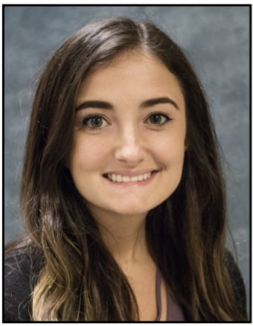

Crystal Fortuna is a nationally certified Physician Assistant, working in geriatric primary care. She graduated with her Bachelor’s degree from the University of Findlay, where she was active in Habitat for Humanity and spent time researching cancer cell growth and microbial growth. She received her Master’s degree from the University of Findlay as well. She is passionate about primary care medicine and educating patients so they can help make informed decisions and become engaged in their healthcare. She is also a big proponent of mental health awareness, and completed her Master’s research on medication treatments for opioid addiction. While completing her clinical rotations, she developed her love of working with geriatric patients.

When Crystal isn’t at work, she enjoys nature and being outdoors, especially hiking with her 6-month-old hound puppy, Hazel. She also loves spending time with her family and friends, going to concerts/live music, and reading. Most of all, she loves exploring downtown Cincinnati, where she lives, and is always the first to try new, local restaurants. Her favorite place to be is on the beach in the Outer Banks of NC, or down south in the Gulf of Mexico. She hopes to be able to visit the west coast sometime soon.

