Meet At Your Door Nurse Practitioner Diana Harless

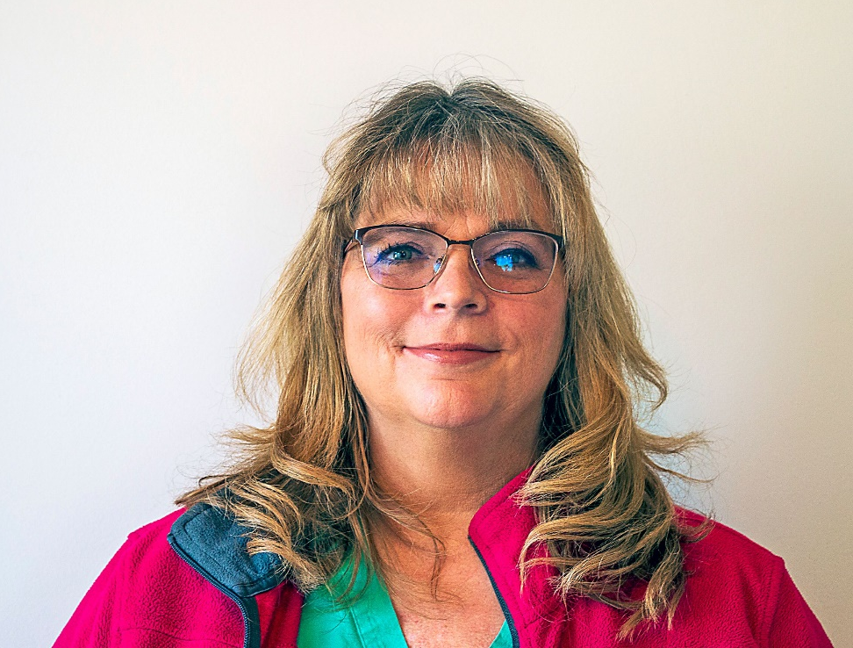
Diana graduated with her ADN in 1996. Her passion was to go back to school once her kids graduated high school but until then, she continued to work as a nurse providing patient care in a variety of settings.

In 2010 when her last child went off to college, she also enrolled to begin her next step in life! Diana obtained her bachelor's degree, and then her family nurse practitioner MSN degree in 2014 from Ohio University. (Go Bobcats!!)

Since graduation until recently, she worked as an NP at Grant Wound Center and worked in various assisted living and skilled nursing facilities. In 2017 she was hired on with At Your Door where she continues to help provide great quality care to our senior population!

Diana loves what she does as a provider: helping not just the patient, but their family members and the staff of her communities.

She is a very family-oriented person! She loves Camping, cats, playing video games, and watching movies. Diana comes from a very large family were there are two sets of twins!

Hello to our valued residents!

We continue to have an exciting relationship with At Your Door: Visiting Healthcare Services and would like to “introduce you” to their services!

At Your Door provides compassionate Nurse Practitioner services to our residents when you need them!

The beauty of their services is that it costs you nothing more than what you pay currently! They will bill your insurance directly and accept nearly all forms of insurance. You may have a co-pay similar to a regular in-office visit. They can provide EVERYTHING that would be done in an office setting while in the comfort of your own home/apartment. They can arrange for x-rays, labs or any therapy in addition to our services if they are ever needed. Their Nurse Practitioner can provide head to toe assessments, care for you when you are not feeling well, order and manage your medications, order and interpret lab results if they are ever needed, and more!

Sometimes, it can be very difficult for you to get to your primary care provider, and for some, it may also be difficult for your family members if they are the ones that must provide that transportation for you. Our personal At Your Door provider becomes your primary care provider and you never have to go out to an office again! Their in-home services also prevent you from encountering the normal germs and viruses that you may come into contact with at a normal doctor’s office, keeping you healthier. You do NOT have to be “home bound” to be seen by At Your Door, but if it is taxing for you or if you have concerns about going out to see your primary care doctor, At Your Door can get your services covered by your insurance.

At Your Door employs some of the best and most compassionate care providers that work directly with…and in coordination with our community’s staff. Your provider will also communicate with any specialists that you may currently see, ensuring a process that is effortless for you, and provides care that you deserve.

Please speak with a member of our Executive team or call the At Your Door office to set up a visit from an At Your Door provider today!

At Your Door: 614-284-4114

