We would like to introduce you to our At Your Door
Nurse Practitioner
Karen Posey!

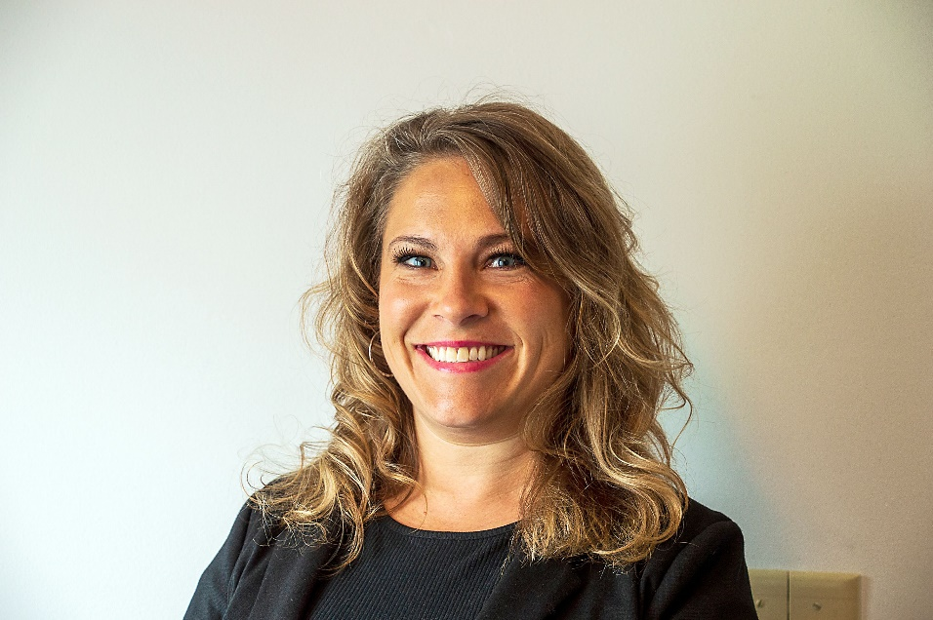
Karen Posey is a Family Care Nurse Practitioner who has been practicing for the past five years in a cardiology practice in Zanesville, OH. She has been working at this location since graduating with her Master’s degree in Nursing from Wheeling Jesuit University in 2015. Prior to her advanced degree, she provided acute care in the Intensive Care Unit at Genesis Healthcare in Zanesville. She holds dual undergraduate degrees in both Education and Nursing from the Ohio State University and Mount Carmel College of Nursing. While earning her degrees she participated in Sigma Theta Tau due to her academic achievements and had the privilege of earning a spot with the Ohio State National Equestrian Team.
Karen is the mother to four amazing children. Her oldest Kadence is 16, followed by Bridgette 14, Piper 9, and Ketcher 6. There is nothing she loves more than being with her children and her husband of 21 years, Ben. Karen spends her spare time working in her yard, riding bikes as a family, hiking local trails, and kayaking on the Kokosing river.
If you see Karen around the building, please stop and welcome her to our community!

Hello to our beloved residents!

We have begun a new relationship with At Your Door: Visiting Healthcare Services and would like to “introduce you” to their services!

At Your Door provides compassionate Primary care health services to our residents when you need them!

The beauty of their services is that it costs you nothing more than what you pay currently! They will bill your insurance directly and accept nearly all insurance. You may have a co-pay similar to a regular in-office visit. They can provide EVERYTHING that would be done in an office setting while in the comfort of your own apartment. They can arrange for x-rays, labs, or any therapy in addition to medical services if they are ever needed. Their Nurse Practitioner can provide head to toe assessments, care for you when you are not feeling well, order and manage your medications, order, and interpret lab results if they are ever needed, and more!

Sometimes, it can be very difficult for you to get to your primary care provider, and for some, it may also be difficult for your family members if they are the ones that must provide that transportation for you. Our personal At Your Door provider becomes your primary care provider and you never have to go out to an office again! Their in-home services also prevent you from encountering the normal germs and viruses that you may encounter at a normal doctor’s office, keeping you healthier. You do NOT have to be “home bound” to be seen by At Your Door, but if it is taxing for you or if you have concerns about going out to see your primary care doctor, At Your Door can get your services covered by your insurance.

At Your Door employs some of the best and most compassionate care providers that work directly with…and in coordination with our community’s staff. Your provider will also communicate with any specialists that you may currently see, ensuring a process that is effortless for you, and provide care that you deserve.

Please speak with a member of our care staff or Executive team to set up a visit from an At Your Door provider today!

