We would like to introduce you to our At Your Door Nurse Practitioner!
Meet Kathryn Holloway!

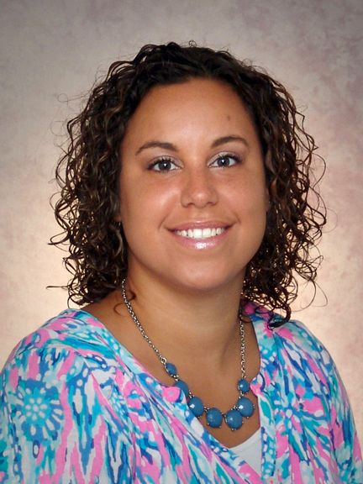

Kathryn graduated with her BSN in 2012 and went on to get her Masters as a Family Nurse Practitioner in 2017.
Kathryn served 8 years in the US Army including 4 of those as a Practical Nursing Specialist!
Kathryn has 7 beautiful children between her and her husband Justin, and when she isn’t working, she coaches cheerleading and baseball. She volunteers with Kettering City Schools to do athletic physicals. She also loves to run!

If you see Kathryn around our halls, please give her a warm welcome!

