Meet At Your Door Nurse Practitioner
Lisa Popovich

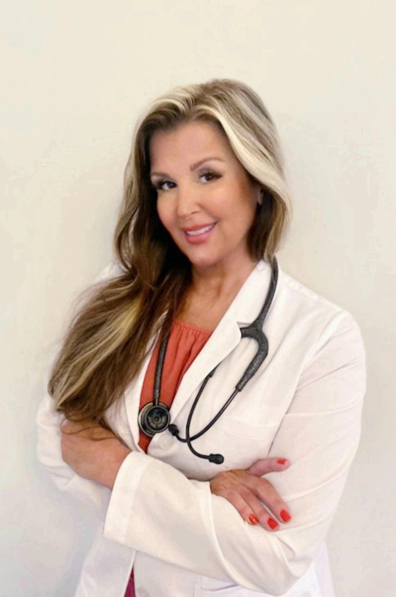
Lisa Ann Popovich is a Board Certified Adult Gerontology Nurse Practitioner. She earned her master of science degree in nursing at Northern Kentucky University with a graduate program focus as an adult gerontology primary care nurse practitioner. She holds national certifications with the American Academy of Nurse Practitioners as well as the American Nurses Credentialing Center. She has enjoyed 11 years of nursing experience at the bedside in various specialties including subacute inpatient care, wound care and outpatient skilled care.

Her passion is caring for the elderly and working with them to maintain a balance for optimal health and wellness through patient driven care.

Away from work she enjoys reading, interior design, traveling, baking and anything related to cosmetology.

