Meet At Your Door: Visiting Healthcare Services
Nurse Practitioner
Megan Langel

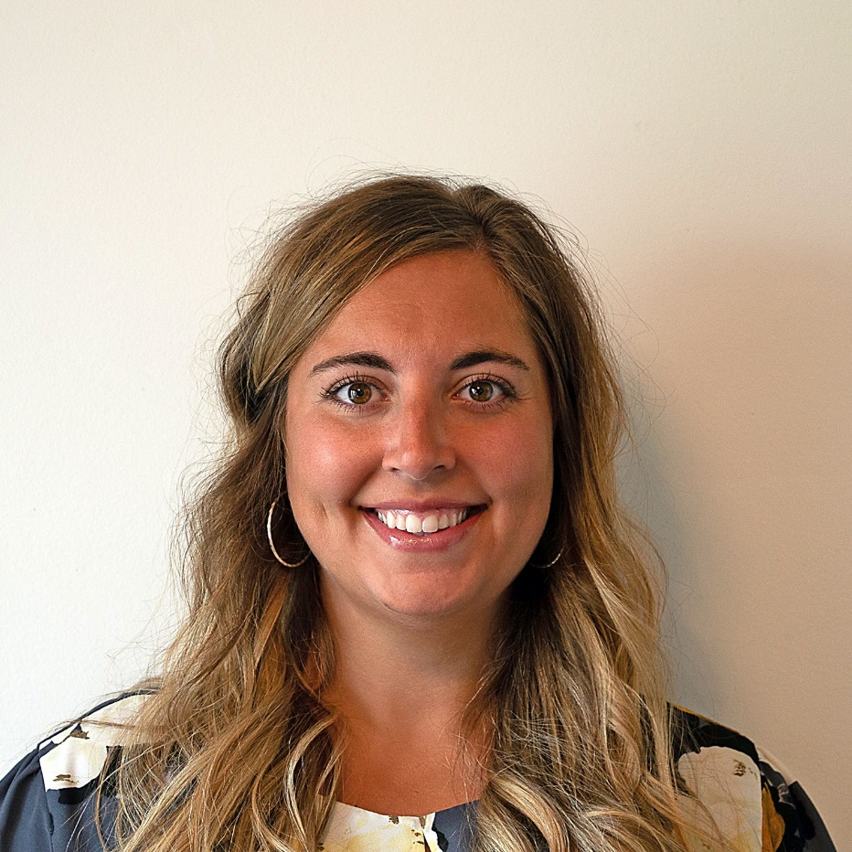

Megan graduated with her Bachelors of Science in Nursing from Capital University in 2016. Most of her nursing career thus far has been spent as an Emergency Room nurse at Riverside Methodist Hospital. She then decided to further her education at The University of Cincinnati and graduated with her Masters of Science in Nursing, as a Family Nurse Practitioner in 2020. Megan lives in Blacklick, OH with her husband Lance. They have been married for 3 years, and have an adorable 4 year old goldendoodle named Cooper. Megan has a love for traveling to see new beaches, but most of all she enjoys spending time with family and friends! Megan looks forward to helping provide exceptional healthcare and creating relationships with the geriatric population in the Columbus area!

