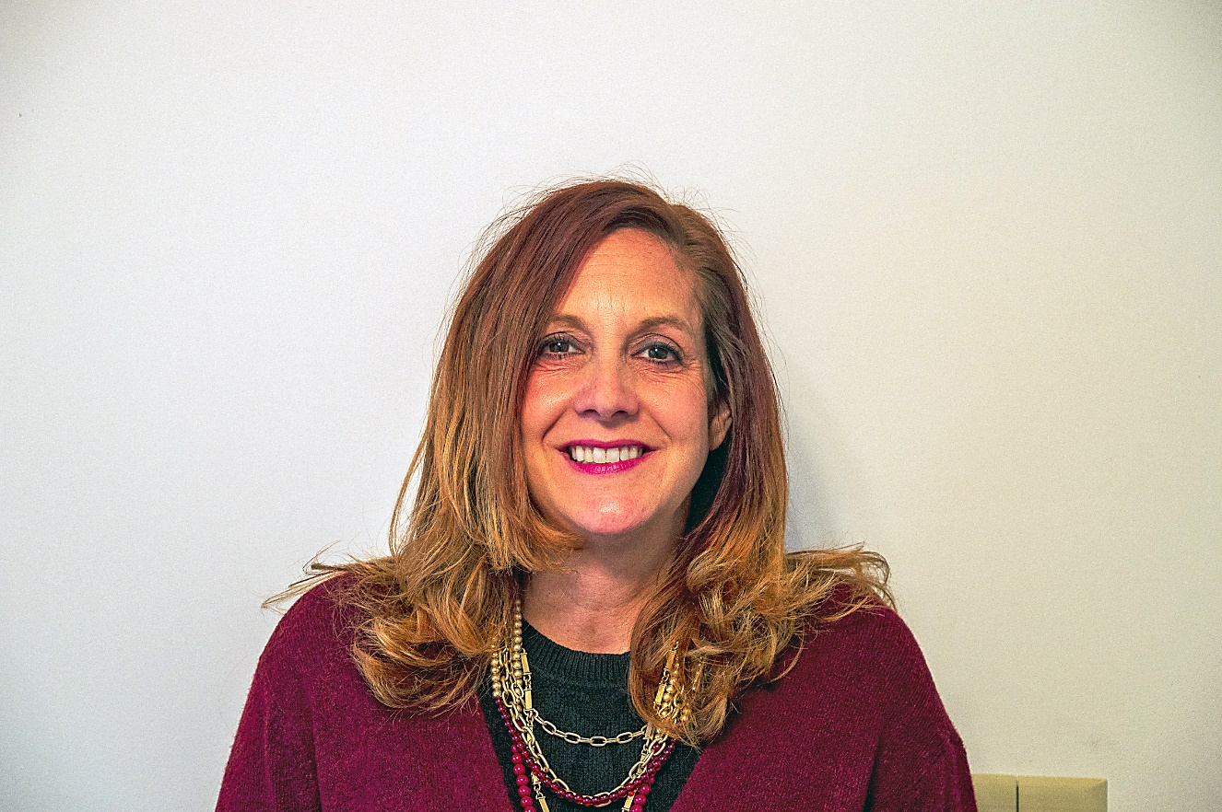

Melinda Everman-Moore (aka Mel) - started her career as an Adjunct Professor in Health Promotion & Exercise Science at
The Ohio State University.
After 15 years of college teaching - she decided she needed a change.
She was accepted into the Graduate Entry Program at Ohio State University where she obtained her RN and then her MSN.
She was a RN case manager in hospice before becoming an NP. Her professional interests are in hospice care, dementia and geriatrics.

When Mel is not caring for her patients, she can be found chasing her twin teenage boys around - she teaches Zumba and Strong by Zumba.

