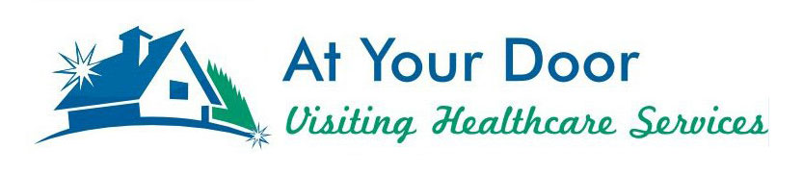
Meet At Your Door Nurse Practitioner Mike Lewis

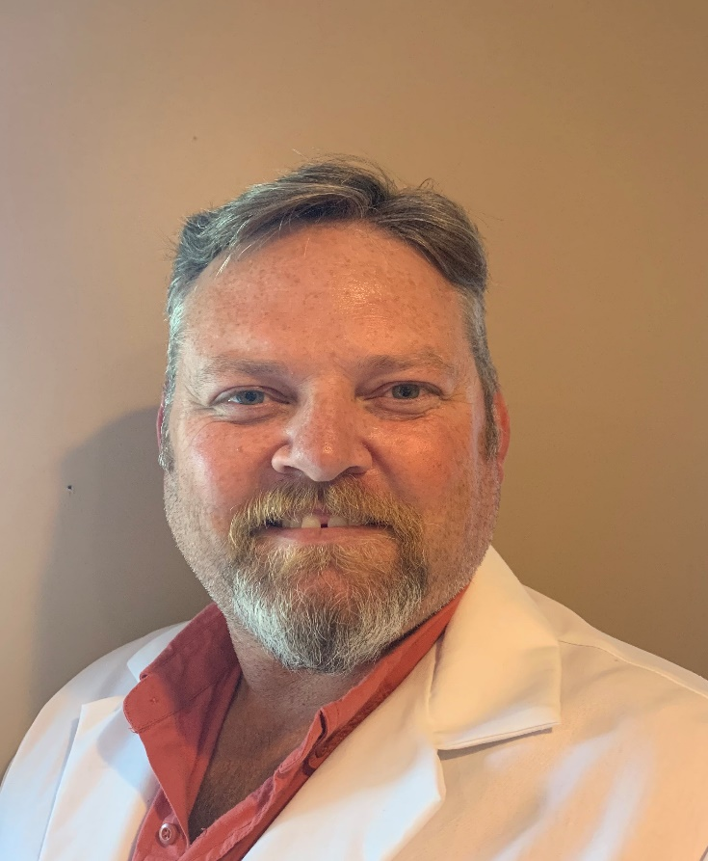
Michael Lewis is a Certified Adult Nurse Practitioner. He was born and raised in Grove City, Ohio, just south of Columbus, and continues to live there with his family consisting of his wife, 6 kids, 3 dogs, 2 of which are Great Danes, and his in-laws. He obtained his undergraduate nursing degree from the Mount Carmel College of Nursing in 2001, and his Master’s degree from Otterbein University in 2009. Michael has spent a majority of his nursing career working in surgery primarily in joint replacements both as a circulating nurse, scrub nurse, and as a first assistant.

When not working, Michael enjoys working on his “honey-do” list completing projects around the house. He is very handy and likes working on projects to make life easier at home. Michael also enjoys spending time with family and friends’ poolside in his backyard. His wife is a nurse manager on an orthopedic floor at The Ohio State University, so conversation is never lacking. Michael looks forward to caring for folks in his “backyard” and supporting families in the Grove City and Columbus areas which he has known all his life.

