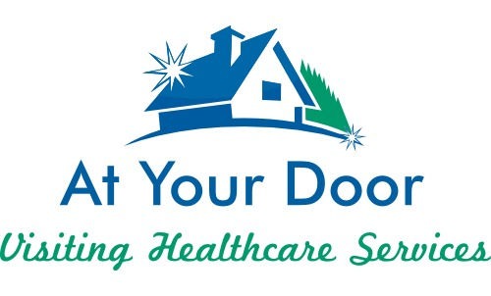

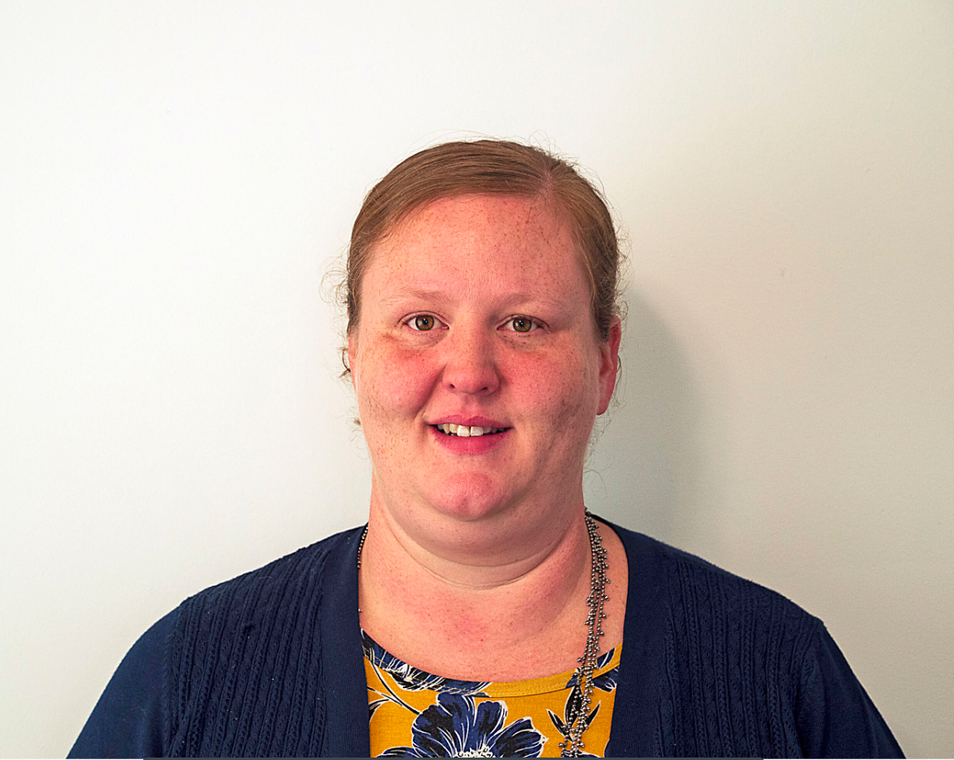

Sarah Hartfield, RN-CNP graduated with her BSN at Mount Carmel College of Nursing in 2003. She did all of her bedside nursing on a medical surgical unit at Mount Carmel West until she graduated with her MSN from Otterbein University in 2013.

After graduation she started at The Ohio State University Medical Center in the department of Family Medicine where she also has experience in urgent care and occupational medicine. However, she has a passion for geriatrics, which is what brought her to At Your Door in the fall of 2018.

Outside of work, Sarah is married and has three children and quite a few furry family members. All three kids play hockey, so if not at work, she will likely be found at the hockey rink. She enjoys gardening, traveling and spending time with her family.

