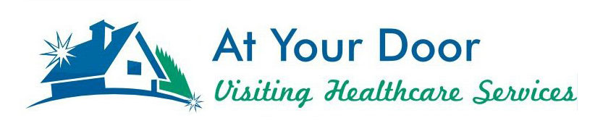
Meet At Your Door
Nurse Practitioner
Sarah Hollis
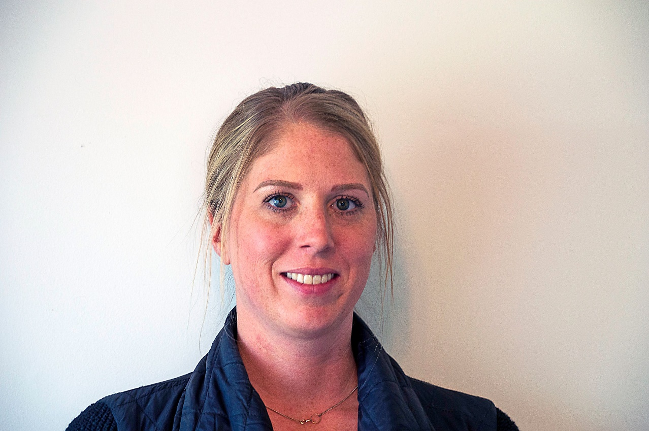

Meet At Your Door Nurse Practitioner Sarah Hollis. Sarah graduated with both her bachelor’s degree and master’s degree from Mount Carmel College of Nursing. Prior to obtaining her master’s degree in 2014, she worked as a floor nurse on a medical surgical unit as well as in the ICU. As a nurse practitioner she has worked in a retail clinic and for the past 3 years have been a part of the At Your Door team. Sarah is married with 3 kids (two boys and one girl) and loves to spend time with family/friends and travel during her free time.

