Meet At Your Door Psychiatric Nurse Practitioner
Tiffany Seneff
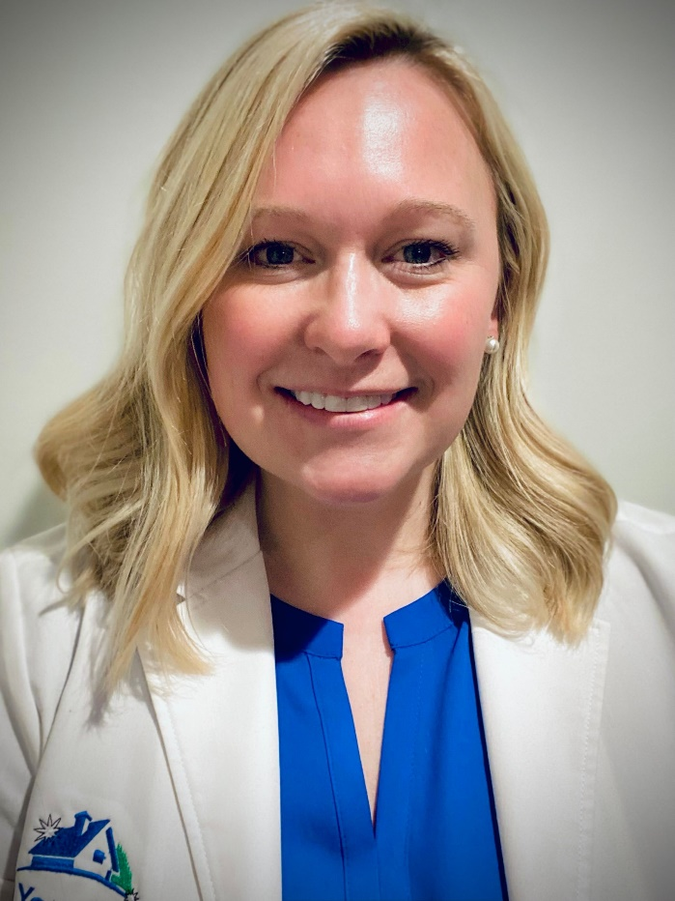
Tiffany is a board-certified Psychiatric Mental Health Nurse Practitioner (PMHNP) with At Your Door. Tiffany holds a Master’s of Science in Nursing from Northern Kentucky University and Bachelor’s of Science from The University of Akron. Tiffany has 14 years of Critical Care, Pediatric Bone Marrow Transplant, and Neuro Interventional experience. Tiffany has a passion for mental health awareness and improving healthcare access to those in need. Tiffany takes pride in being a strong advocate for her patients and the community.
During her time away from work she enjoys reading, traveling and spending time with her husband and 4-year-old twin boys.

