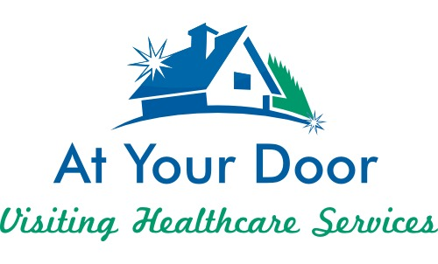
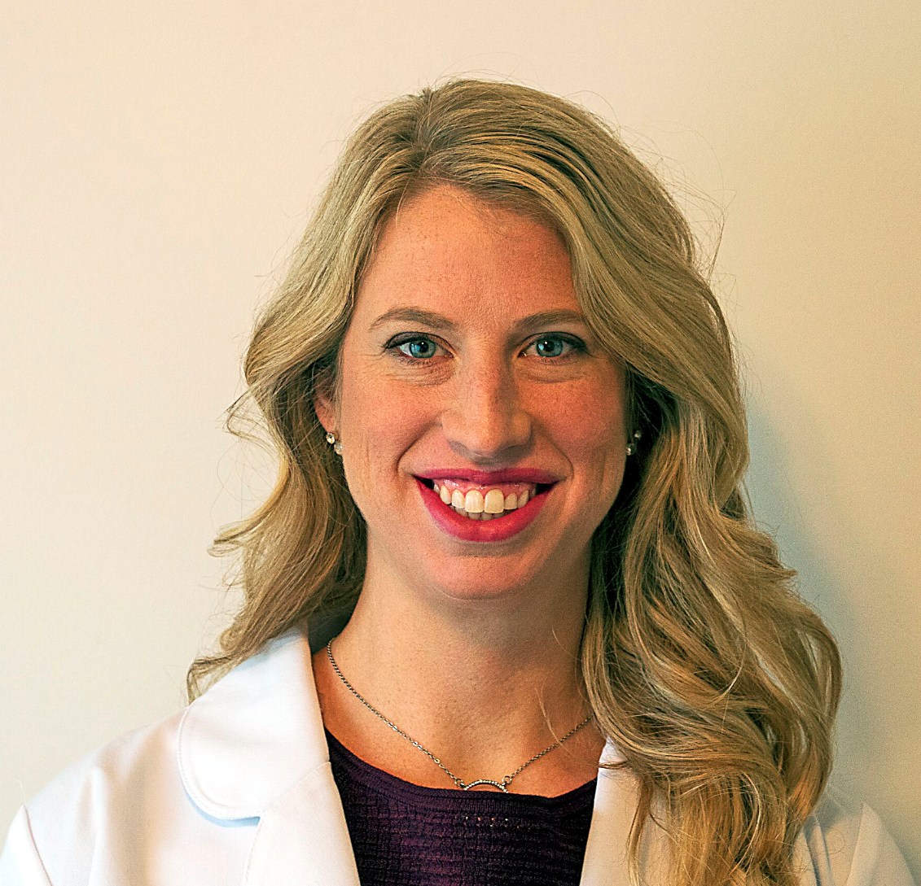

Valarie Langel has been a Nurse Practitioner since May 2014. She has been a part of the At Your Door team since June 2017 seeing patients in skilled nursing facilities, long-term care, and assisted living. She graduated from Otterbein University with honors and obtained her Family Nurse Practitioner Certification. She is board certified with the American Association of Nurse Practitioners.
She has been a registered nurse since 2010, and was an RN at Riverside Methodist Hospital in cardiology and med-surg prior to her NP. She has worked as an NP in many areas, such as urgent care and gastroenterology.
Valarie is married to her husband Matt, and they have two children, Savannah and Brayden. She resides in Pataskala, Ohio on a small cattle farm.
She has a passion for geriatrics and truly loves her residents like they are her own family. She is outgoing, energetic, and passionate about her patients. She knows no stranger and becomes friends with everyone she meets. She is a great asset to our team!

