Dear valued client;

We at At Your Door Visiting Healthcare Services want to thank you for trusting us for your care, or the care of your loved one! We promise that we will always do what is right and do our very best to ensure the medical care we provide is always top notch!
Although we never anticipate losing a provider, sometimes situations are simply out of our control. If we ever need to replace a provider in your community, you will receive notification via mail of that change along with the bio of the new provider. We also want you to know that you will always have the option to continue to be seen by the new At Your Door provider. Legally, you always have the right to have the provider of your choice and this choice can never be made by anyone but you, your family members or Power of Attorney.

If you have family members that are involved in your care, please share this information with them and make them aware of provider changes if and when they should ever occur. If you ever have any questions, please speak to the staff of your community or call us at 614-284-4114.

New Patient Referral
At Your Door: Visiting Healthcare Services  314 Agler Road, Suite B  Gahanna, OH 43230  T: 614-284-4114 F: 614-245-4389  www.atyourdoorhealthcare.com | 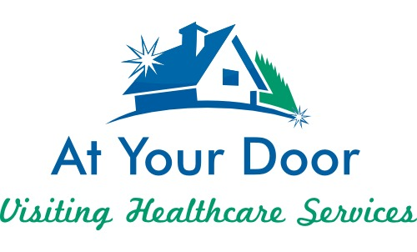

Please complete the following and return along with any records.
Thanks for your referral.

Patient Name:________________________________ Facility:___________________________
DOB: _______________________________________ Social Security #: ___________________
Address:_______________________________________________________________________
Home #: _____________________________________ Cell #: ___________________________
Email Address: _________________________________________________________________
POA Name: ___________________________________ Contact #: ________________________
POA Address: __________________________________________________________________
Email address: __________________________________________________________________
Primary Insurance: ______________________________ ID #:____________________________
Secondary Insurance: ____________________________ ID #: ___________________________
Medicaid #: ____________________________________ Medicare #: _____________________

Please check box that applies:
Came from hospital (please provide name of hospital): _______________________________
Came from Home
Transfer from another facility (please provide name): ________________________________
Transfer within facility

314 Agler Road, Suite B
Gahanna, OH 43230
614/284-4114 Fax 614/245-4389

CONSENT TO TREATMENT

_______________________ [name of resident] (the “Resident”), is hereby aware that a provider of At Your Door: Visiting Healthcare Services, will be providing care in collaboration with their individual collaborating physician.

The Practitioner will provide services within the Practitioner’s scope of practice. The Practitioner will also provide services in collaboration with the Physician pursuant to the standard care arrangement between the Practitioner and the Physician required under Ohio law. The appropriate payer(s) will be billed for care the Practitioner provides.

The Resident hereby consents and agrees to the Practitioner (this may consist of a Physician Assistant, Family Nurse Practitioner, Adult-Gerontology Practitioner, Acute Care Practitioner, Psychiatric Mental Health Practitioner, and/or Wound Nurse Practitioner) rendering care. The Resident acknowledges that he/she has the right to refuse any treatment by any health care provider and to be informed of the consequences of refusing the treatment.

The Resident hereby consents to payment to the Practitioner not covered by their insurance.

Dated: ________________________ | ____________________________________  Resident Signature
Dated: ________________________ | ____________________________________  Responsible Party/POA

Address for billing purposes: (Financial POA)_________________________________________________

Legal Status of Responsible Party: (check one)
Guardian: _________
Healthcare Power of Attorney: _________
Financial Power of Attorney: __________

We participate in one or more Health Information Exchanges. Your healthcare providers can use this electronic network to securely provide access to your health records for a better picture of your health needs. We, and other healthcare providers, may allow access to your health information through the Health Information Exchange for treatment, payment or other healthcare operations. This is a voluntary agreement. You may opt-out at any time by notifying your Nurse Practitioner.

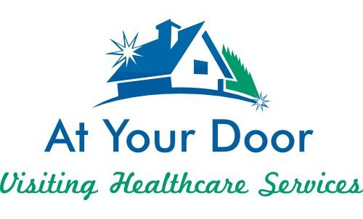

CONSENT FOR RELEASE OF MEDICAL RECORDS
I do hereby consent and authorize you to release copies of my medical records, including current and previous medical records from other practices and practitioners, hospitals, and/or clinics, which are a part of my medical records. PLEASE NOTE: This authorization includes consent for the release of alcohol, drug, psychiatric and psychological information and any information relating to pregnancy, sexually transmitted diseases, HIV testing, AIDS, and any AIDS-related syndromes. It also includes any information concerning cancer, cancer testing, and cancer results. I agree that a copy of this release or a fax of this release shall be as valid as this original release. Please send copies of all requested information as soon as possible to the address listed below:
Patient’s Name _____________________________________________________________
Patient’s Address ___________________________________________________________
Patient’s Date of Birth ________________________________________________________
Patient’s Social Security Number ______________________________________________
Please release my medical records from (Name, Address, Phone Number, Fax Number): _________________________________________________________________________ _________________________________________________________________________ _________________________________________________________________________
Please send my medical records to:
At Your Door Healthcare Services
314 Agler Road, Suite B
Gahanna, OH 43230
Or fax to 614-245-4389

Patient’s Signature: ___________________________________ Date: _______________
Parent/Guardian (If a minor) ____________________________ Date: _______________
Witness: ____________________________________________ Date: _______________

314 Agler Road, Suite B
Gahanna, OH 43230
614/284-4114 Fax 614/245-4389

PSYCHIATRIC MENTAL HEALTH CONSENT TO TREATMENT

_______________________[name of resident] (the “Resident”), is hereby aware that a Psychiatric Mental Health Nurse Practitioner (PMHNP) of At Your Door: Visiting Healthcare Services, will be providing care in collaboration with their individual collaborating physician.

The PMHNP will provide services within the Practitioner’s scope of practice. The Practitioner will also provide services in collaboration with the Physician pursuant to the standard care arrangement between the Practitioner and the Physician required under Ohio law. The appropriate payer(s) will be billed for care the Practitioner provides.

The Resident hereby consents and agrees to the PMHNP rendering care. The Resident acknowledges that he/she has the right to refuse any treatment by any health care provider and to be informed of the consequences of refusing the treatment.

The Resident hereby consents to payment to the Practitioner not covered by their insurance.

Dated: ________________________ | ____________________________________  Resident Signature
Dated: ________________________ | ____________________________________  Responsible Party/POA

Address for billing purposes: (Financial POA) _________________________________________________

Legal Status of Responsible Party: (check one)
Guardian: __________
Healthcare Power of Attorney: ________
Financial Power of Attorney: ________

We participate in one or more Health Information Exchanges. Your healthcare providers can use this electronic network to securely provide access to your health records for a better picture of your health needs. We and other healthcare providers, may allow access to your health information through the Health Information Exchange for treatment, payment or other healthcare operations. This is a voluntary agreement. You may opt-out at any time by notifying your Nurse Practitioner.

